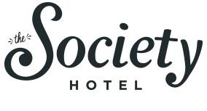
Winter 2016 - 2017 Influencer Expectations

@josephpadiernos (11k followers)

Objective
The Society Hotel works with content creators and influencers to strengthen our position in existing markets as well as to test new markets. Currently, our target audience includes budget-conscious, young travelers looking for a “Portland” experience and Oregon locals looking for “staycation” destinations. Our brand makes a concerted effort to acknowledge and celebrate our building and neighborhood’s historical significance. At the same time, we want our visual content to convey that we are a contemporary and fresh take on traditional hotels.

Compensation
The Society Hotel will offer accommodations for the dates of Jan. 9 - 13 at one of the following media rates of your choosing:
- Bunk Room (free)
- Queen Standard Private Room ($37/night)
- Suite ($79/night)
Please note that all prices do not include the 12% lodging tax collected by the city of Portland.

Deliverables
In exchange for discounted lodging, the influencer will make two posts to their Instagram channel and deliver five copyrighted images for use on the hotel’s proprietary social media. Failure to follow through with deliverables will result in the guest being charged full price for their stay.

